first choose the best JMS for the lab After
I choose Artemis

why Artemis and what’s the deference between it with other JMS ( RabbiMQ and Classic ):

The JMS Landscape: A Quick Overview
First, it's important to understand that JMS (Java Message Service) is just a specification, like a blueprint. To actually send and receive messages, you need a JMS provider, which is the real-world implementation. The three main open-source contenders you’ll encounter are:
- Apache ActiveMQ Artemis (The Modern Workhorse)
- Apache ActiveMQ Classic (The Legacy Standard)
- RabbitMQ (The Polyglot Performer)

Head-to-Head Comparison: Why Artemis is the Best Fit
Let's compare them across the five dimensions that matter most for your decision.

Performance & Consistency
- Artemis: Built for high throughput and low latency using a non-blocking, asynchronous core (Netty). It maintains consistent performance even under high concurrency, which is crucial for accurate lab measurements. It boasts benchmark results of over 15,000 persistent messages per second, while using resources efficiently.
- ActiveMQ Classic: Its older, blocking I/O model can struggle under high load, with performance often degrading as connections increase. This makes its test results less predictable.
- RabbitMQ: While performant (around 59,500 msg/sec in some tests), its performance is highly dependent on configuring AMQP-specific features. Translating JMS calls to its native AMQP protocol adds an extra layer and potential variability.

🏛️ Native JMS Support (Critical for Your Lab)
- Artemis: Its core architecture was built from the ground up to be a first-class JMS 2.0 citizen, offering the best compatibility and full feature support like shared subscriptions and delayed delivery.
- ActiveMQ Classic: Supports the older JMS 1.1 specification but lacks JMS 2.0 features. This is a major limitation for a modern lab environment.
- RabbitMQ: This is the biggest hurdle. It is not a native JMS broker. It requires a separate JMS client library (rabbitmq-jms) that acts as a translator, which can lead to subtle specification deviations and make porting Java code harder.

Tooling & Metrics (For Your Performance Tests)
- Artemis: Ships with built-in command-line perf tools (producer, consumer, client) specifically designed for JMS performance testing, giving you a massive head start. It also works seamlessly with standard JMS load-testing tools like Apache JMeter.
- ActiveMQ Classic: Primarily relies on third-party tools for detailed performance metrics, adding complexity to your test setup.
- RabbitMQ: Features a renowned management UI, but the information is from an AMQP perspective, which is less intuitive for measuring JMS performance.

Usability & Code Clutter
- Artemis: The cleanest option. Zero broker-side XML configuration is needed to start using queues and topics, as they are auto-created on demand. A simple Docker Compose file and your standard JMS code are all you need.
- ActiveMQ Classic: Also allows for auto-creation of destinations, but configuring advanced features in its broker XML can be more involved.
- RabbitMQ: Introduces code-level complexity. You must use non-standard JMS code to manage its AMQP-centric entities (exchanges and bindings) before you can send a message.

Ecosystem & Future-Proofing
- Artemis: A modern, actively developed top-level Apache project. Its multi-protocol support and native Spring Boot integration future-proof your learning. It natively supports JMS, AMQP, MQTT, and STOMP.
- ActiveMQ Classic: A stable, mature project. However, it's in maintenance mode, and the community is steadily migrating towards Artemis.
- RabbitMQ: Boasts an excellent ecosystem with strong multi-language support. However, it introduces vendor lock-in concerns, and lacks a unified management console for multi-protocol environments.

The Final Verdict: ActiveMQ Artemis is the Ideal Candidate
For your lab, Apache ActiveMQ Artemis is the superior and most logical choice. Here’s a summary of the compelling reasons:
- ✅ Purpose-Built for JMS: It's the only modern, open-source broker designed from the core to be a 100% compliant JMS 2.0 provider, avoiding the performance and compatibility issues that alternatives face.
- ✅ Best Performance Testing Tools: Its built-in perf tools are invaluable for a lab focused on measuring response time, throughput, and latency.
- ✅ Lowest Complexity: The "auto-create" feature means you can achieve a working setup with a minimal Docker Compose file and simple Java code, reducing the "code clutter" mentioned in your lab requirements.
- ✅ Alignment with Kafka: It represents a modern, high-performance message broker, making it the most credible and fair counterpart to compare against Kafka.

Now it Setup time:
to setup Artemis is very it’s one of it’s advantages
you just need a very simple docker compose like this :

version: '3'
services:
artemis:
image: apache/activemq-artemis:latest
container_name: artemis
environment:
- ARTEMIS_USER=admin
- ARTEMIS_PASSWORD=admin
- ANONYMOUS_LOGIN=false
ports:
- "61616:61616" # JMS Port
- "8161:8161" # Web Console Port
volumes:
- artemis_data:/var/lib/artemis/data
volumes:
artemis_data:
Then create a Maven Project just put this in the lab path

mvn archetype:generate \
-DgroupId=com.lab.jms \
-DartifactId=jms-artemis-tests \
-DarchetypeArtifactId=maven-archetype-quickstart \
-DarchetypeVersion=1.4 \
-DinteractiveMode=false

Now replace the pom.xml with:

<project xmlns="http://maven.apache.org/POM/4.0.0"
xmlns:xsi="http://www.w3.org/2001/XMLSchema-instance"
xsi:schemaLocation="http://maven.apache.org/POM/4.0.0
http://maven.apache.org/xsd/maven-4.0.0.xsd">
<modelVersion>4.0.0</modelVersion>

<groupId>com.lab.jms</groupId>
<artifactId>jms-artemis-tests</artifactId>
<version>1.0-SNAPSHOT</version>

<properties>
<maven.compiler.source>11</maven.compiler.source>
<maven.compiler.target>11</maven.compiler.target>
</properties>

<dependencies>
<!-- Artemis JMS client (Jakarta namespace) -->
<dependency>
<groupId>org.apache.activemq</groupId>
<artifactId>artemis-jakarta-client</artifactId>
<version>2.34.0</version>
</dependency>
<!-- Needed for the client to log (optional but helps) -->
<dependency>
<groupId>org.slf4j</groupId>
<artifactId>slf4j-simple</artifactId>
<version>1.7.36</version>
</dependency>
</dependencies>

<build>
<plugins>
<plugin>
<groupId>org.apache.maven.plugins</groupId>
<artifactId>maven-compiler-plugin</artifactId>
<version>3.11.0</version>
</plugin>
<plugin>
<groupId>org.codehaus.mojo</groupId>
<artifactId>exec-maven-plugin</artifactId>
<version>3.1.0</version>
</plugin>
</plugins>
</build>
</project>

take care here
<properties>
<maven.compiler.source>11</maven.compiler.source>
<maven.compiler.target>11</maven.compiler.target>
</properties>
i use Java 11 put your version
Build once to fetch dependencies:
mvn clean compile

yeah I forget open http://localhost:8161/console/login
and login using admin admin
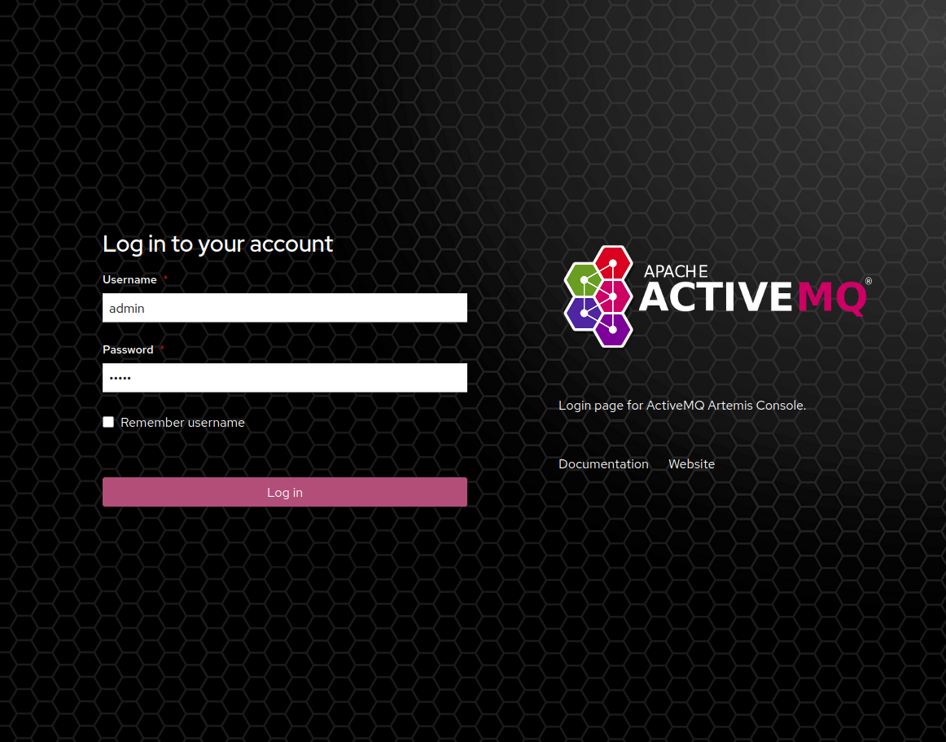
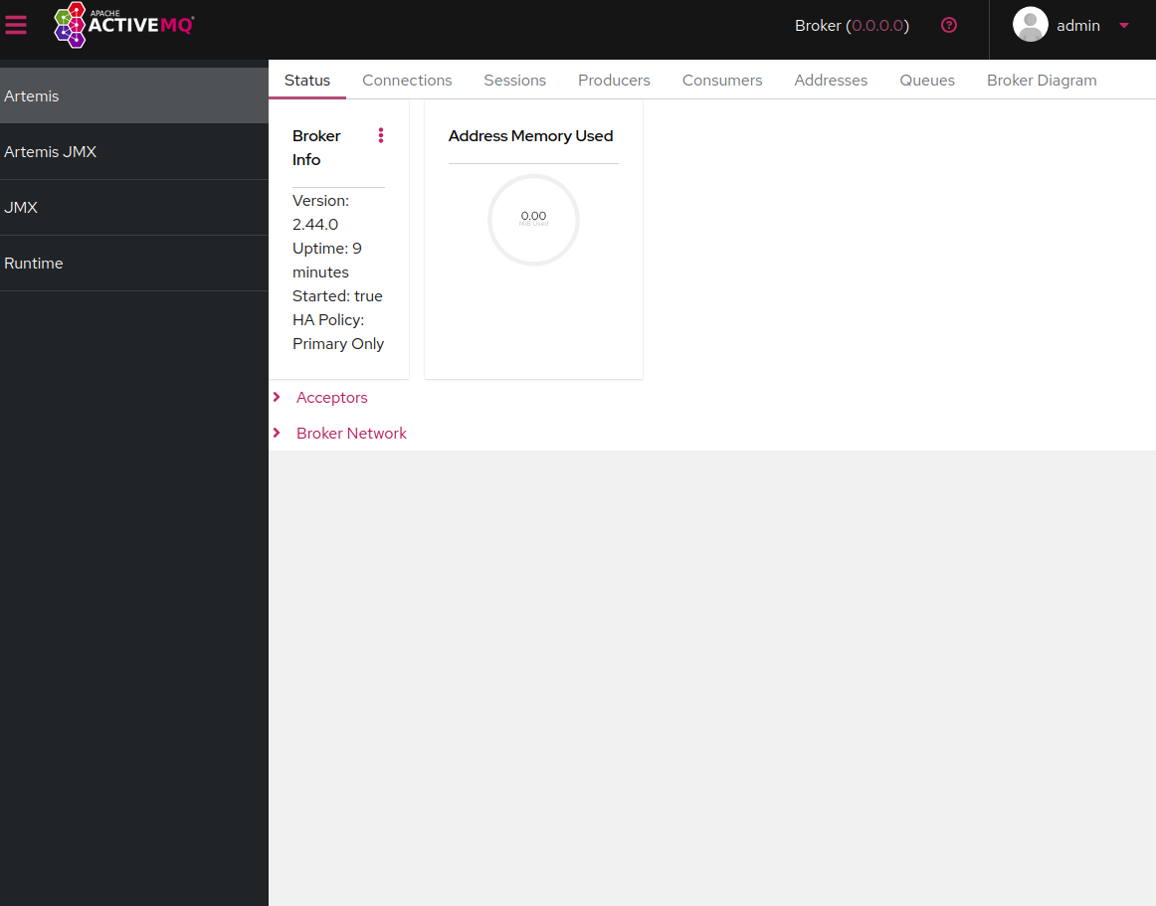

ok now lets make the producer go from the JMS folder paht go to src/main/java/com/lab/jms
then in jms folder create Producer.java
package com.lab.jms;

import org.apache.activemq.artemis.jms.client.ActiveMQJMSConnectionFactory;
import javax.jms.*;
import java.util.Random;

public class Producer {
public static void main(String[] args) throws Exception {
// --- CONFIGURATION ---
String brokerUrl = "tcp://localhost:61616"; // Artemis JMS port
String queueName = "PERF_TEST_QUEUE"; // auto-created by Artemis
int messageCount = 10000; // for performance tests
byte[] payload = new byte[1024]; // 1 KB message body
new Random().nextBytes(payload); // fill with random data

// --- CREATE CONNECTION AND SESSION ---
ConnectionFactory factory = new ActiveMQJMSConnectionFactory(brokerUrl);
try (Connection connection = factory.createConnection("admin", "admin");
Session session = connection.createSession(false, Session.AUTO_ACKNOWLEDGE)) {

// Destination (queue) – automatically created if not present
Destination destination = session.createQueue(queueName);
MessageProducer producer = session.createProducer(destination);
producer.setDeliveryMode(DeliveryMode.NON_PERSISTENT); // faster, no disk write

// --- SEND MESSAGES ---
for (int i = 0; i < messageCount; i++) {
// 1. Create a 1 KB binary message
BytesMessage message = session.createBytesMessage();
message.writeBytes(payload);

// 2. Attach the current timestamp for later latency calculation
message.setLongProperty("SEND_TIME", System.currentTimeMillis());

// 3. Measure the response time of the send() call
long start = System.currentTimeMillis();
producer.send(message);
long responseTime = System.currentTimeMillis() - start;

// 4. Output progress (Member 4 can collect these values)
System.out.printf("Sent msg %d | Producer response time: %d ms%n", i, responseTime);
}
System.out.println("All " + messageCount + " messages sent.");
}
}
}

take care from this line it depend on u Java version :
import jakarta.jms.*;

What the Measurement Hooks Do
- Response Time: The time producer.send() takes is measured directly. That's one of the lab metrics.
- Latency Setup: Each message carries a SEND_TIME property. The consumer (that I'll write next) will read this and compute consumeTime – SEND_TIME. The median of those differences is your median latency.
- 1 KB Payload: As required by the lab instructions.
Test the Producer

then back to JMS/jms-artemis-test and run
mvn clean compile

now lets implement consumer
in path src/main/java/com/lab/jms/
create Consumer.java
package com.lab.jms;

import org.apache.activemq.artemis.jms.client.ActiveMQJMSConnectionFactory;
import jakarta.jms.*;
import java.util.ArrayList;
import java.util.Collections;
import java.util.List;

public class Consumer {
public static void main(String[] args) throws Exception {
// --- CONFIGURATION ---
String brokerUrl = "tcp://localhost:61616";
String queueName = "PERF_TEST_QUEUE";
int expectedMessages = 10000; // must match producer count

List<Long> latencies = new ArrayList<>();

// --- CREATE CONNECTION AND SESSION ---
ConnectionFactory factory = new ActiveMQJMSConnectionFactory(brokerUrl);
try (Connection connection = factory.createConnection("admin", "admin");
Session session = connection.createSession(false, Session.AUTO_ACKNOWLEDGE)) {

connection.start(); // CRITICAL: starts message delivery

Destination destination = session.createQueue(queueName);
MessageConsumer consumer = session.createConsumer(destination);

System.out.println("Consumer ready. Waiting for messages...");

// --- RECEIVE MESSAGES ---
for (int i = 0; i < expectedMessages; i++) {
// 1. Measure consume response time
long start = System.currentTimeMillis();
Message msg = consumer.receive(); // blocking call
long consumeResponseTime = System.currentTimeMillis() - start;

// 2. Calculate end-to-end latency
long sendTime = msg.getLongProperty("SEND_TIME");
long latency = System.currentTimeMillis() - sendTime;
latencies.add(latency);

// 3. Output progress
System.out.printf("Received msg %d | Consume response time: %d ms | Latency: %d ms%n",
i, consumeResponseTime, latency);
}

// --- CALCULATE MEDIAN LATENCY ---
Collections.sort(latencies);
long median;
int size = latencies.size();
if (size % 2 == 0) {
median = (latencies.get(size / 2 - 1) + latencies.get(size / 2)) / 2;
} else {
median = latencies.get(size / 2);
}

System.out.println("============================================");
System.out.printf("Results: %d messages processed.%n", size);
System.out.printf("Median latency: %d ms%n", median);
System.out.println("============================================");
}
}
}

ok good now lets test all the system

first run the consumer at path JMS/jms-artemis-tests

mvn exec:java -Dexec.mainClass="com.lab.jms.Consumer"
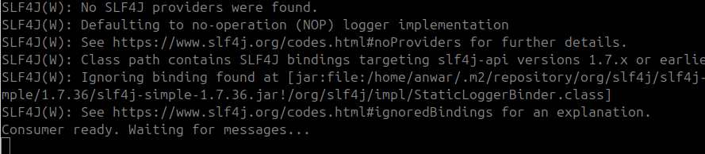

then producer
mvn exec:java -Dexec.mainClass="com.lab.jms.Producer"

perfect
